Nepal College of information Technology
Imadol lalitpur
Unit Test Fall Semester 2006/2007

Program: CE/ELX Semester: II
Time: 2hrs Year: I

FM 50 PM: 25

Electronic Devices

Candidates are required to give their answers in their own words as far as practicable.
The marks allotted for each sub-question is specified along its side.
Attempt all questions.

1 [a] Explain, with reference to energy band theory the difference between conductor, insulator and semiconductors. [5]
[b] Distinguish between intrinsic and extrinsic semiconductor. What are donor and acceptor impurities? [5]

2 [a] Explain the two mechanisms of breakdown in a PN junction diode. [5]
[b] Draw the V-I characteristics of tunnel diode. Briefly describe the mechanism of junction breakdown. [5]

3 [a] Define diffusion capacitance of a p-n junction diode. Obtain an expression for the same. [8]
[b] Why is the diffusion capacitance negligible for a reverse biased diode? [2]

4 [a] Explain the characteristics of a Zener diode. How it can be used as a voltage Regulator. [7]

5 [a] Determine V₀ and I for the network shown in figure 5a. [5]
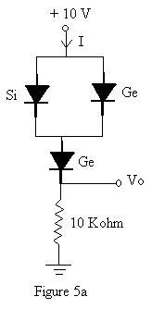

[6] Write short notes on any two: [4 x 2 = 8]

[i] Diode switching time
[ii] Varactor diode
[iii] Schottky diode

